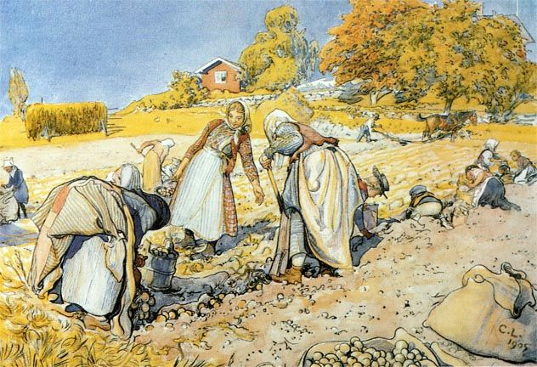

Carl Larsson – Potato Harvest, Watercolor, 1905

Carl Larsson writes: ”The children are off school to help with the potatoes. … Johan is ploughing our field in Kartbacken followed by a potato mobilized gang of women and children. It is a really good potato slope just below the church house. Everyone is smiling. We shall not want! Ah, these potatoes! With fresh or fried salted herring.”

People depended on the harvest and their livestock for food and everyone in the family worked hard to keep hunger and poverty at bay.

At that time there were seven farms in central Sundborn. Today there is only one on the outskirts of the village that has livestock.



Carl Larsson – Potato Harvest, Watercolor, 1905

Carl Larsson writes: ”The children are off school to help with the potatoes. … Johan is ploughing our field in Kartbacken followed by a potato mobilized gang of women and children. It is a really good potato slope just below the church house. Everyone is smiling. We shall not want! Ah, these potatoes! With fresh or fried salted herring.”

People depended on the harvest and their livestock for food and everyone in the family worked hard to keep hunger and poverty at bay.

At that time there were seven farms in central Sundborn. Today there is only one on the outskirts of the village that has livestock.